Software Design Document
< Online Tourist Guide >



Submitted by:
Muhammad Ubaid Akbar
Roll No: F22BINFT1M01173
Submitted to:
Ms. Sara Farid

Department of Information Technology
Faculty of Computing
The Islamia University of Bahawalpur

Summary
The Online Tourist Guide is a web-based designed to help tourists explore, search, and book tours easily. This Software Design Description (SDD) explains the complete design structure of the system, including architecture, data design, components, and user interface.
The main purpose of this SDD is to describe both preliminary and final design phases of the project. It explains how system components, diagrams (class, ER, component), and architectural designs are integrated to build a functional tourist guide system.
The system targets users who travel to new places and need guidance. It allows:
- Online access via a website
- Offline access through a mobile application
- GPS-based automatic location information
- Tour discovery, booking, and management
Users can explore locations before visiting and use the mobile app during travel.
The system is divided into modules such as:
- Users
- Tours (Add, View, Edit, Delete)
- Search (Basic & Advanced)
- Booked Tours
Design rationale is used to:
- Support system reuse and future changes
- Improve software quality
- Transfer design knowledge effectively
Key features include:
- Guest and registered user access
- Tour searching and viewing
- Tour booking and confirmation
- Secure data storage
- Online payment handling

Table of contents
1. INTRODUCTION 3
1.1 Purpose 3
• Preliminary design, 3
• Final design. 3
1.2 Scope 3
1.3 Overview 4
1.4 Reference Material 4
1.5 Definitions and Acronyms 4
2. SYSTEM OVERVIEW 5
3. SYSTEM ARCHITECTURE 6
3.1 Architectural Design 6
3.2 Decomposition Description 7
3.3 Design Rationale 8
4. DATA DESIGN 9
4.1 Data Description 9
4.2 Data Dictionary 10
Admin table 10
5. COMPONENT DESIGN 14
Component diagram for Tour 14
Component diagram for booked tour 15
6. Interface Design 16
6.1 Overview of User GUI 16
6.2 Screen Images 17
6.3 DISPLAY OBJECTS AND ACTIONS 19
8. APPENDICES 23

INTRODUCTION

1.1 Purpose:
The second phase of project development is design. Design itself can be sub-divided into as many steps as necessary to resolve all design problems and to integrate the concepts into a functional facility plan and also we develop different diagrams to elaborate the application that we want to make. It is generally recommended that at least two stages are used. These are:

Preliminary design,
During the preliminary design stage, major emphasis is upon class diagram, ER-diagram, and architectural design. The design of all the mechanical processes will also be completed at this time to ensure that they are integrated properly into the structures of our application.

- Final design.
During the final design stage the detailed architectural and engineering drawings of all physical components of the project are produced. In some complex projects, such as multi-disciplinary research centres, it is necessary to prepare in addition a written final design report. This summarizes the facility as designed.

1.2 Scope:
Now a day’s people use mobile devices and mobile phones. People use these gadgets for calling, as a calendar, planner and organizer. Mobile phones with GPS facility are also used to find paths in navigation. The main idea of this project is to design the system that will run on mobile phones, which will be helpful when visiting some new places. The proposed mobile tourist guide design consists of two steps, the first step is designing a web site that allows the user to navigate a web site, discover the locations and the interesting points before the real visit. The second step is designing the mobile applications. When the user visits the web site, selects the points that he wants to visit and specifies some preferences such as the visit duration, the mobile model, and the language, then the information about these locations are kept over the user space and an application is being built. The application must be now installed in his mobile phone. The user runs the application while visiting. He accesses the information from a simple interface or the information about any location is displayed without the user intervention according the GPS positioning system, where the matching is done between the GPS coordination and the GPS dimensions stored for each location over the device. If so, the information about this location is displayed. The system is designed to allow tourist to work in on-line from the web site or off-line mode from the installed application over the mobile device.

1.3 Overview:
In this SDD we define the working nature of Online Tourist Guide and we also check how our system work in admin and user panel both.

1.4 Reference Material:
- www.google.com.pk
- http://creately.com/diagram/example/hdbs9w7f1/Component%20Diagram%20Hotel%20Management
- www.uml-diagrams.org/component-diagrams.html
- https//openai.com

1.5 Definitions and Acronyms:
HTML | HYPERTEXT MARKUP LANGUAGE
PHP | HYPERTEXT PREPROCESSOR
CSS | CASCADING STYLE SHEET
XHTML | EXTENSIBLE HYPERTEXT MARKUP LANGUAGE

2. SYSTEM OVERVIEW
Online Tourist Guide
User
Admin

Order
Upload tour
View detail
Receive order

3. SYSTEM ARCHITECTURE

3.1 Architectural Design:

3.2 Decomposition Description:
Online Tourist Guide

Tours
Find
New Tour
Users
Add
View
Edit
Del
Basic
Advance
Make
View
Booked
Add
View

3.3 Design Rationale:
Basically this portion will explain the architecture of our system link “online Tourist Guide”. This will helpful for the structure and working of our system. Visualization is the common process for create rationale. Here first we identify our problem statement and then we evaluate solution of our problem by using different algorithms. Choose the best solution for our problem and then we start our work.
The rationale structure of our web based application “online Tourist Guide”
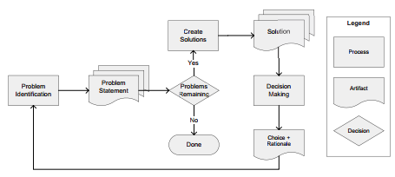
Why we choose design rationale in design phase
- Supporting reuse and change
- Improving quality
- Supporting knowledge transfer.

4. DATA DESIGN

4.1 Data Description:

WE NEED
1) HTML5
2) PHP
3) LOCAL SERVER (localhost)
4) MYSQL

4.2 Data Dictionary:

Admin table
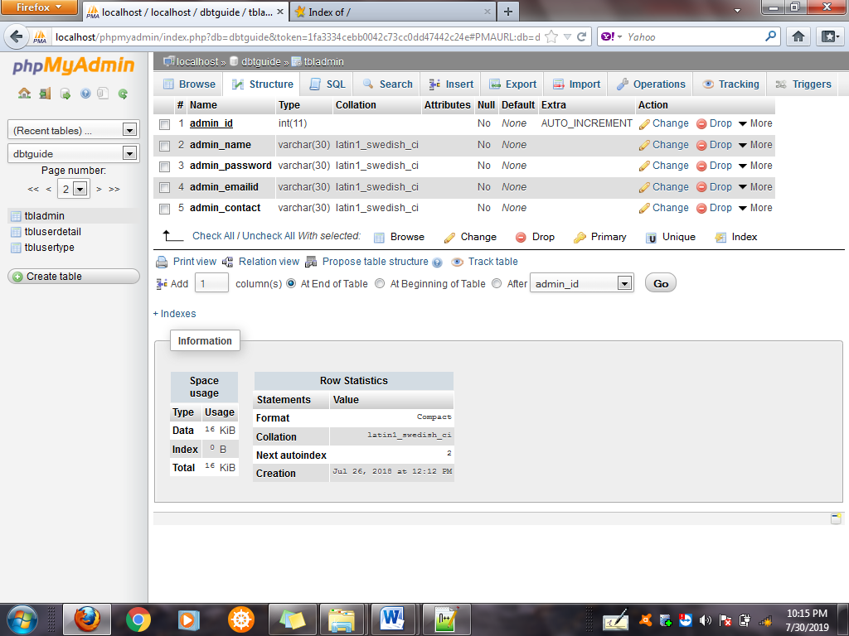

tblsignup
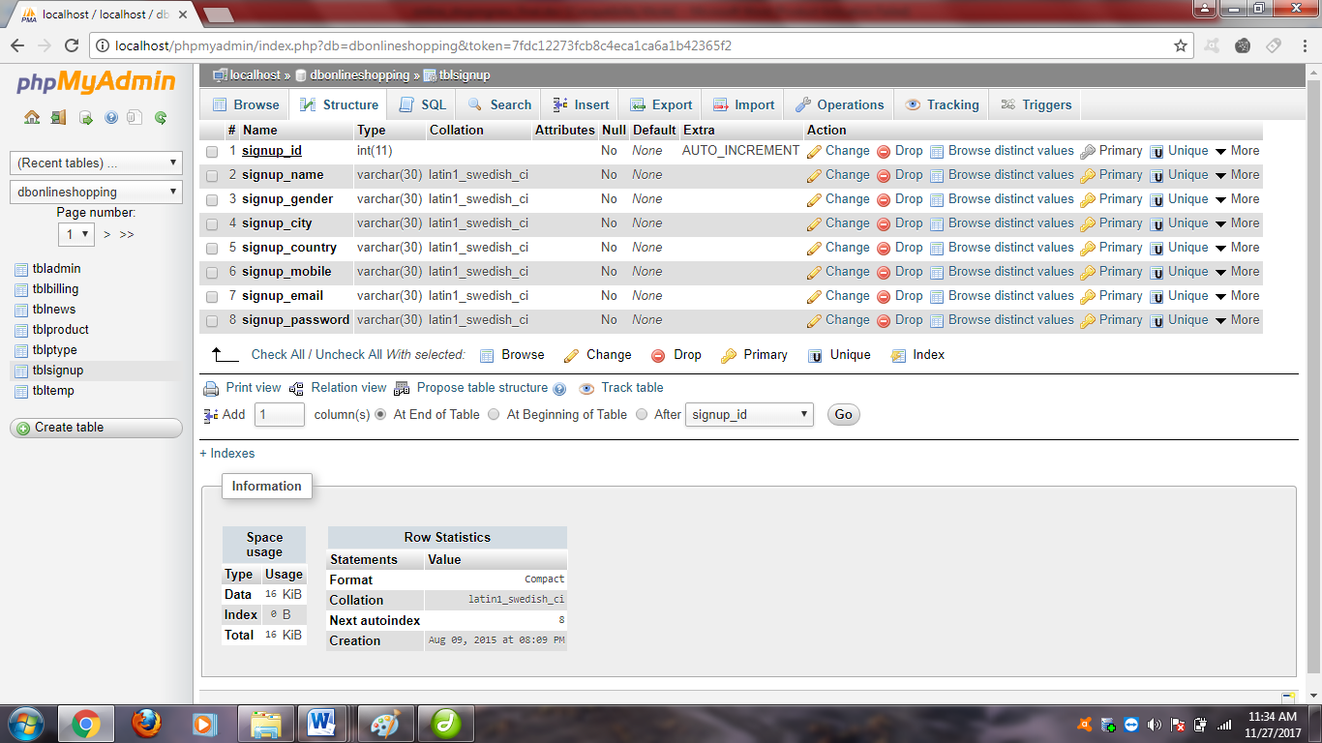

tbltour
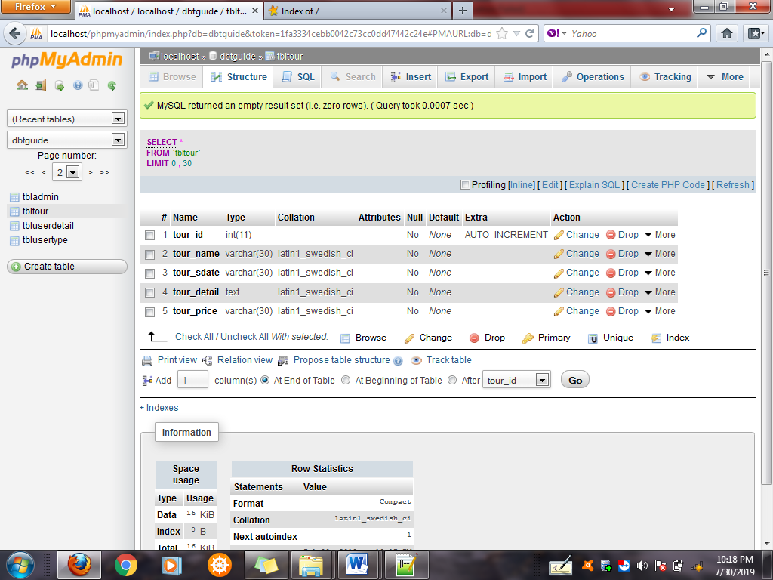

tblbooked

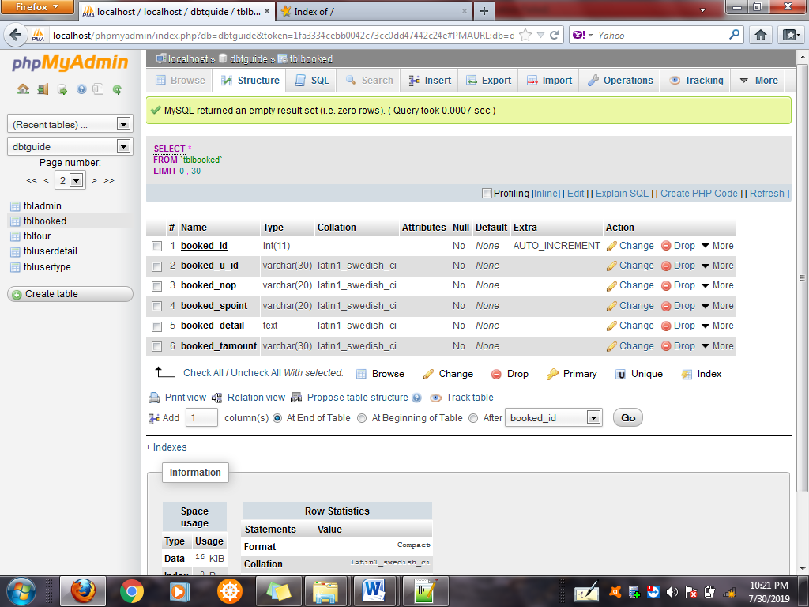

5. COMPONENT DESIGN

Component diagram for Tour

Component diagram for find/searches

Component diagram for booked tour

6. Interface Design

6.1 Overview of User GUI:
The main purpose of user interface is to show our actual application interface. This can show that how user use this application and on clicking of which button which option can called.

6.2 Screen Images:
Some User Interface Screen Images are as follows

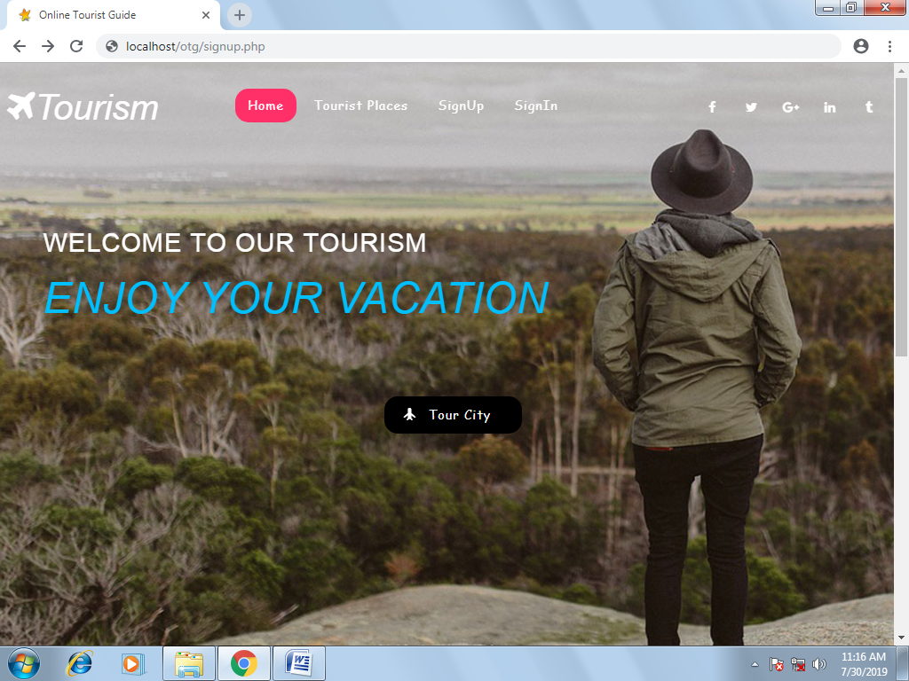
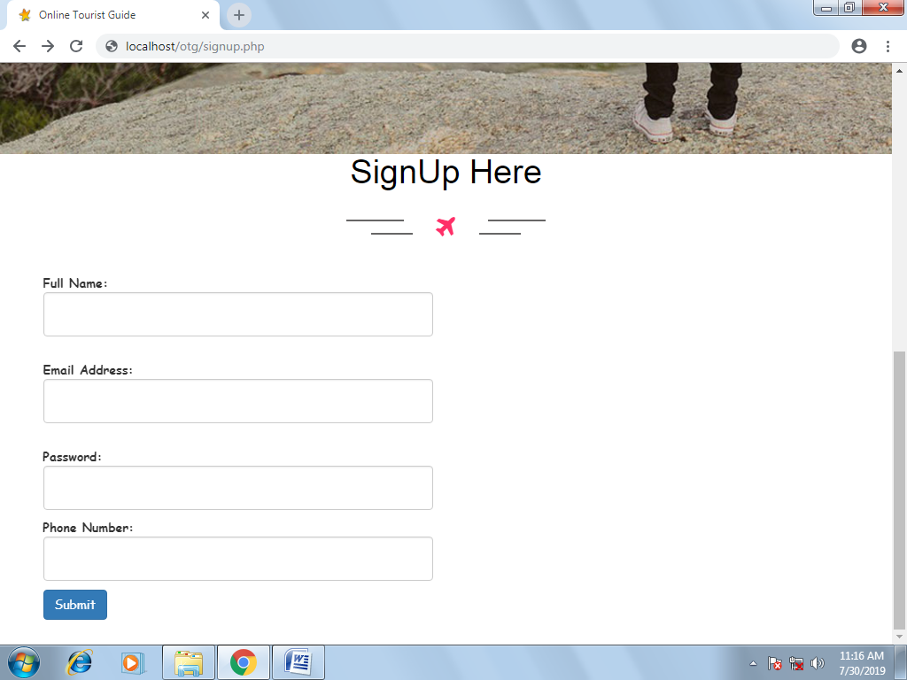

6.3 DISPLAY OBJECTS AND ACTIONS:

Our Screen Items is that
- Index / Home
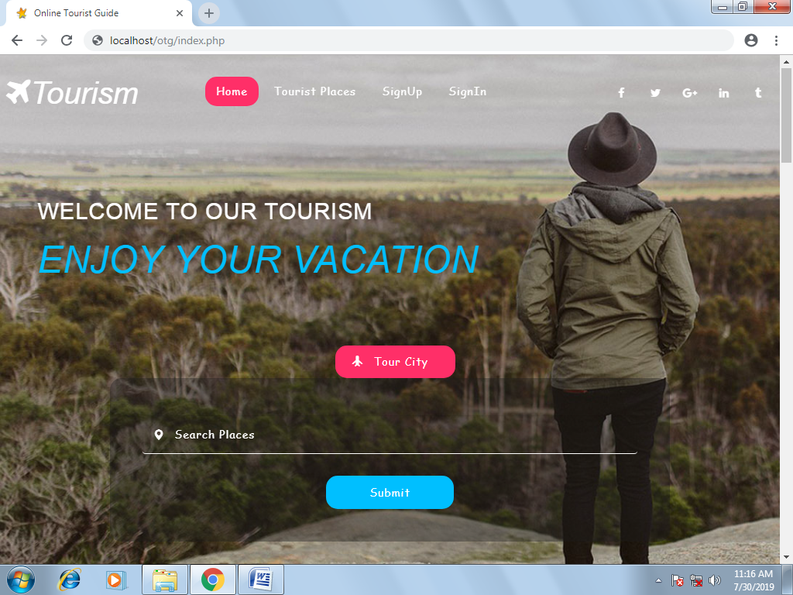

- Sign Up
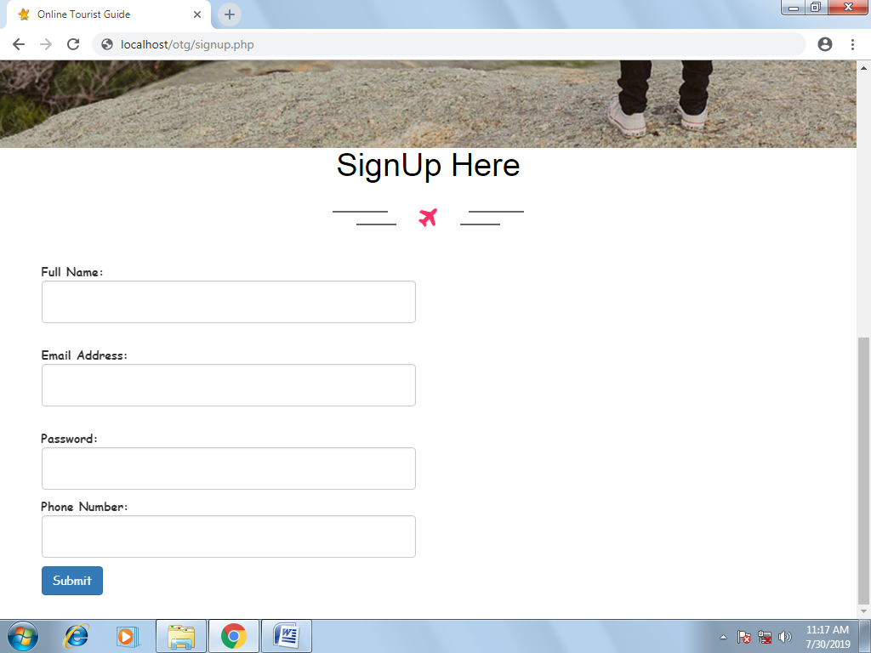

- Login
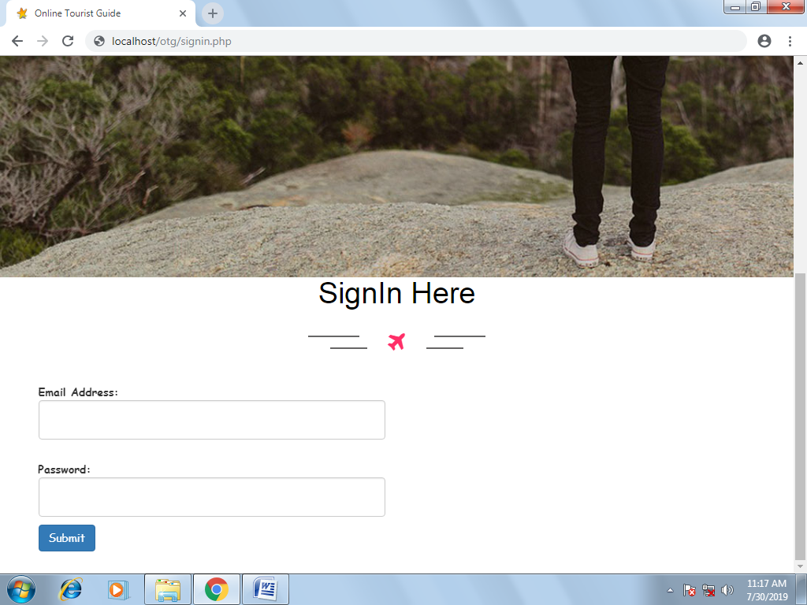

7. REQUIREMENTS DETAIL
ID | User Requirements | Forward Traceability
U1 | Registered and Guest User Allowed | S1, S3, S4
U2 | User Find Tours | S5
U3 | User Login as Guest | S1,S3,S4
U4 | Tour Detail for User | S1,S3,S5
U5 | Booked Tours | S1,S3,S6
U6 | Received Confirmation | S1,S3,S7

ID | System Functional Requirements | Forward Traceability
S1 | Login / Registered Page Should be Display | U1
S2 | User is accepted by the System when all the relative information correct | U1
S3 | Data store by the System | U1
S4 | Guest user allowed to find tours | U2
S5 | Booked Tours Should be allowed to place in a System | U2
S6 | Received Confirmation for order by the user in a system | U3
S7 | Registered User amount the Bill through the System | U3

8. APPENDICES

- No need of extra software
- No need of extra hardware
- Only Browser
- Internet Connection

